WORK CASE №5

***Готував матеріал студент Бродзінський Є.В.***

1. При роботі з персональним комп’ютером дуже часто виникає необхідність підключати периферійне обладнання. На прикладі принтера та флешки опишіть який механізм має ОС Linux для роботи з ними.

- В чому суть операції монтування, для чого вона використовується та як?

The essence of the mount operation is that it allows the OS to perceive external devices, such as flash drives or printers, as part of the file system. For devices that are not embedded in the system, mounting is necessary to make them available for reading and writing.

How does it work? When we connect a flash drive or a printer, Linux automatically detects this device and assigns a mount point to it. After we can open and edit files on the device through this mount point.

- В чому різниця при роботі з периферією у ОС Linux та ОС Windows?

The difference in working with peripherals between Linux OS and Windows OS:

Windows mount mechanism does not have the same mount concept as in Linux. Usually, when we connect a flash drive or other external device to Windows OS, it can automatically recognize the device and give it a drive letter ("D:"). That is, we can work with the device as with the files on this disk.

Ease of use: In Windows, the process of working with peripherals is more simplified thanks to automatic recognition and assignment of drive letters. In Linux, the user must be aware of mount points and perform some actions to access external devices. And because of this, Linux is considered more difficult in the process of working with peripherals.

***Готував матеріал студент Тунда Р.О. і Кравченко Т.І.***

2. Підключіть до вашої віртуальної машини зі встановленою ОС Linux флешку та принтер (за можливості) та через графічний інтерфейс скопіюйте один файл з флешки на віртуальну машину та роздрукуйте його (такі ж самі дії повторіть, але з іншим файлом через команди в терміналі).

* I connected the flash drive through the virtual machine settings

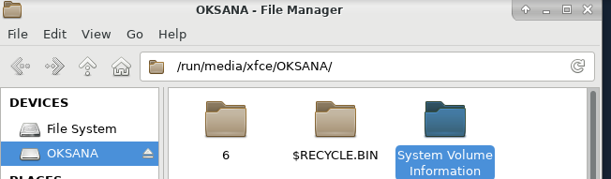

* I took an arbitrary file from a flash drive and transferred it to a VM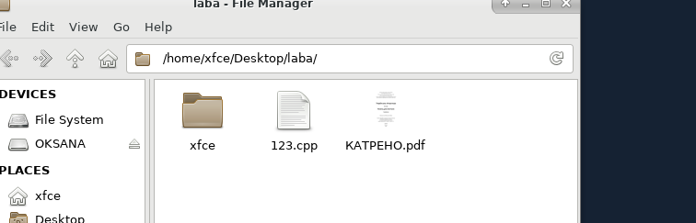
* Added a printer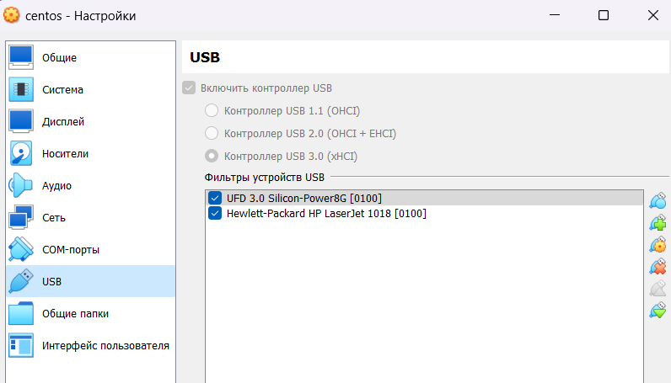
* Installed the guest driver for the printer using the command:

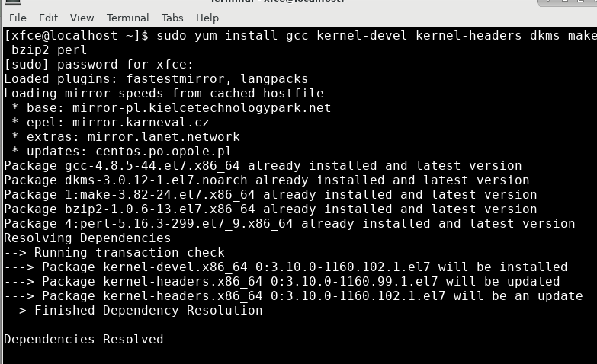

* After that, he restarted the VM and started printing the selected file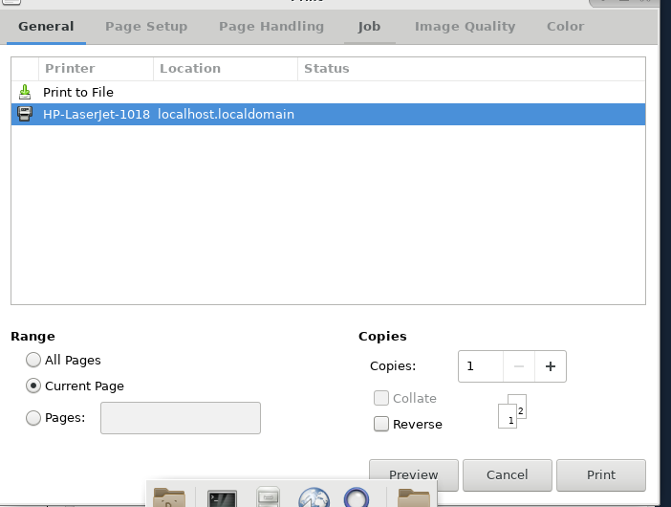

**Through the terminal:**

Unfortunately, we did not have access to a printer, so we made an instruction that will help to complete the tasks. P.S. some screenshots are missing for the same reason.

1. Connect the flash drive to the virtual machine: Insert the flash drive into the USB port of the physical machine and add it to the virtual machine.

2. Check whether the system recognized the flash drive:

Open a terminal on the virtual machine and type `lsblk` or `lsusb` to make sure the flash drive is recognized.

3. Copy the file from the flash drive to the virtual machine:

Using the command line, copy the file from the flash drive to the virtual machine. For example, if the flash drive is mounted in `/media/usb`, use the `cp` command to copy the file:

cp /media/usb/file_name /path_to_where_to_copy

4. Print the file:

To print a file on a printer, you must first make sure that it is properly connected to the virtual machine. We use the `lp` command to print the file, for example:

lp /file_path

* Work result:

